Team Number: 3

Team Members: Austin, Kristina, Charles

| **Attribute Name** | **Entity** | **A/C[1]** | **E/D[2]** | **S/M[3]** | **M/O[4]** | **Unique?** | **Definition** |
| --- | --- | --- | --- | --- | --- | --- | --- |
| Reservation_ID | Reservation | A | E | S | M | Yes | The reservation identifier. |
| Medication_ID | Medication | A | E | S | M | Yes | The medication identifier. |
| Discount_ID | Discount | A | E | S | M | Yes | The discount identifier. |
| Customer_ID | Customer | A | E | S | M | Yes | The customer identifier. |
| Pet_ID | Pet | A | E | S | M | Yes | The pet identifier. |
| Vaccination_ID | Vaccination | A | E | S | M | Yes | The vaccine identifier. |
| Service_ID | Service | A | E | S | M | Yes | The service identifier. |
| Food_ID | Food | A | E | S | M | Yes | The food identifier. |
| Food_Schedule | Pet | A | E | S | M | No | If a pet is fed once or twice per day. |
| Run_ID | Run | A | E | S | M | Yes | The run identifier. |
| Suite_ID | Suite-ID | A | E | S | M | Yes | The suite identifier. |
| Dog Rate_ID | Dog Rate-ID | A | E | S | M | Yes | The dog-rate identifier. |
| Cat Rate_ID | Cat-rate | A | E | S | M | Yes | The cat-rate identifier. |
| Medication_Name | Medication | A | E | S | M | No | The medication’s name. |
| Discount_Amount | Discount | A | E | S | M | No | The amount of the discount. |
| Customer_First_Name | Customer | A | E | S | M | No | The customer’s first name. |
| Pet_Name | Pet | A | E | S | M | No | The customer’s last name. |
| Vaccination_name | Vaccination | A | E | S | M | No | The vaccine name. |
| Service_rate | Service | A | E | S | M | No | The rate for the service. |
| Food_Name | Food | C | E | S | M | No | The food’s name. |
| Suite_Type | Cat-Suite | A | E | S | M | No | What kind of suite (luxury, regular, semi-luxury). |
| Suite-status | Suite | A | E | S | M | No | If the suite is occupied. |
| Cat_Rate_Amount | Cat Rate | A | E | S | M | No | The rate amount for a cat. |
| Dog_Is_Barker | Dog | A | E | S | M | No | If the dog is a barker. |
| Dog_Is_Climber | Dog | A | E | S | M | No | If the dog is a climber. |
| Dog_Rate_Amount | Dog rate | A | E | S | M | No | The rate amount for a dog. |
| Dog_Size | Dog | A | E | S | M | No | If the dog is small, medium, or large. |
| Service_Type | Service | A | E | S | M | No | Type of service that is offered. |
| Note_ID | Special-Note | A | E | S | M | No | Identifier for the note. |
| Note_Info | Special-Note | C | E | S | M | No | The note’s contents. |
| Cat_Litter_trained | Cat | A | E | S | M | No | If the cat is litter trained. |
| Cat_In_Outdoor | Cat | A | E | S | M | No | If the cat is an indoor or outdoor cat. |
| Vaccine_expiration | Pet_vaccination | A | E | S | M | No | The date that the vaccine for a pet expires. |
| run_type | Run | A | E | S | M | No | If the run is covered or uncovered. |
| Run_status | Run | A | E | S | M | No | If the run is occupied. |
| Run_direction | Run | A | E | S | M | No | Which way the run faces. |
| Reservation_start_date | Reservation | A | E | S | M | No | The start date for the reservation. |
| Reservation_end_date | Reservation | A | E | S | M | No | The end date for the reservation. |
| Dog_breed | Dog | A | E | S | M | No | The dog’s breed. |
| Medication_Dose | Medication | A | E | S | M | No | The dose for the medication. |
| Medication_note | Medication | C | E | S | M | No | A special note for medication. |
| Pet_sex | Run | A | E | S | M | No | The pet’s sex. |
| Pet_age | Run | A | E | S | M | No | The pet’s age. |
| Run_Size | Run | A | E | S | M | No | If the run has a large or small door. |
| Cat_breed | Cat | A | E | S | M | No | The cat’s breed. |
| Customer_Last_Name | Customer | A | E | S | M | No | The customer’s last name. |
| Customer_Phone-Number | Customer | C | E | S | M | No | The customer’s phone number. |
| Customer_Emergency_First_Name | Customer | A | E | S | M | No | The customer’s emergency contact’s first name. |
| Customer_Emergency_Last_Name | Customer | A | E | S | M | No | The customer’s emergency contact’s last name. |
| Customer_Emergency_Phonenum | Customer | A | E | S | M | No | The customer’s emergency phone number. |
| Customer_Street | Customer | A | E | S | M | No | Customer’s street address. |
| Customer_City | Customer | A | E | S | M | No | The city in which the customer lives. |
| Customer_Province | Customer | A | E | S | M | No | The province in which the customer lives. |

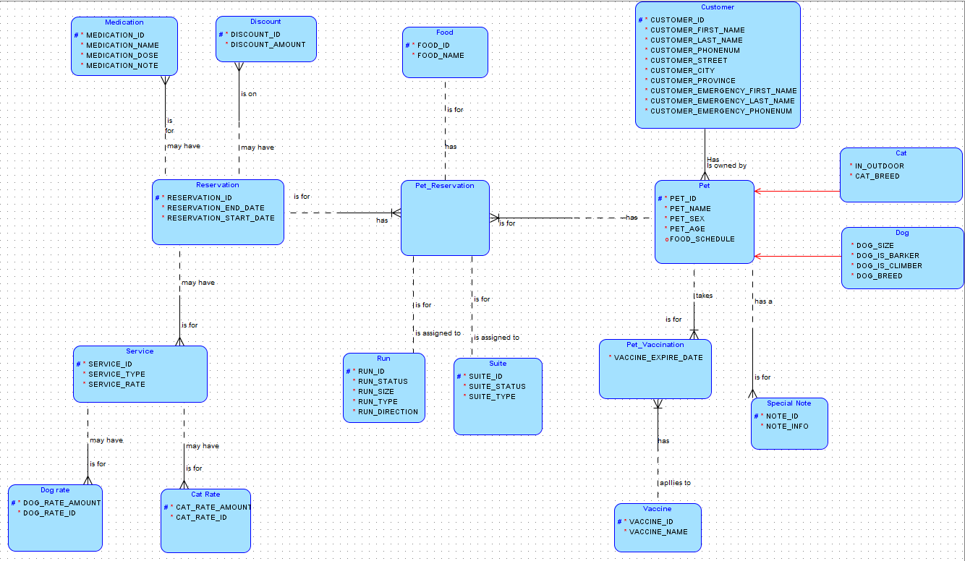

1. **Atomic (A) or Composite (C)**
2. **Explicit (E) or Derived (D)**
3. **Singular(S) or Multi-valued (M)**
4. **Mandatory (M) or Optional (O)**